**Task-2:**

1. Show persons who acted in any Movie:

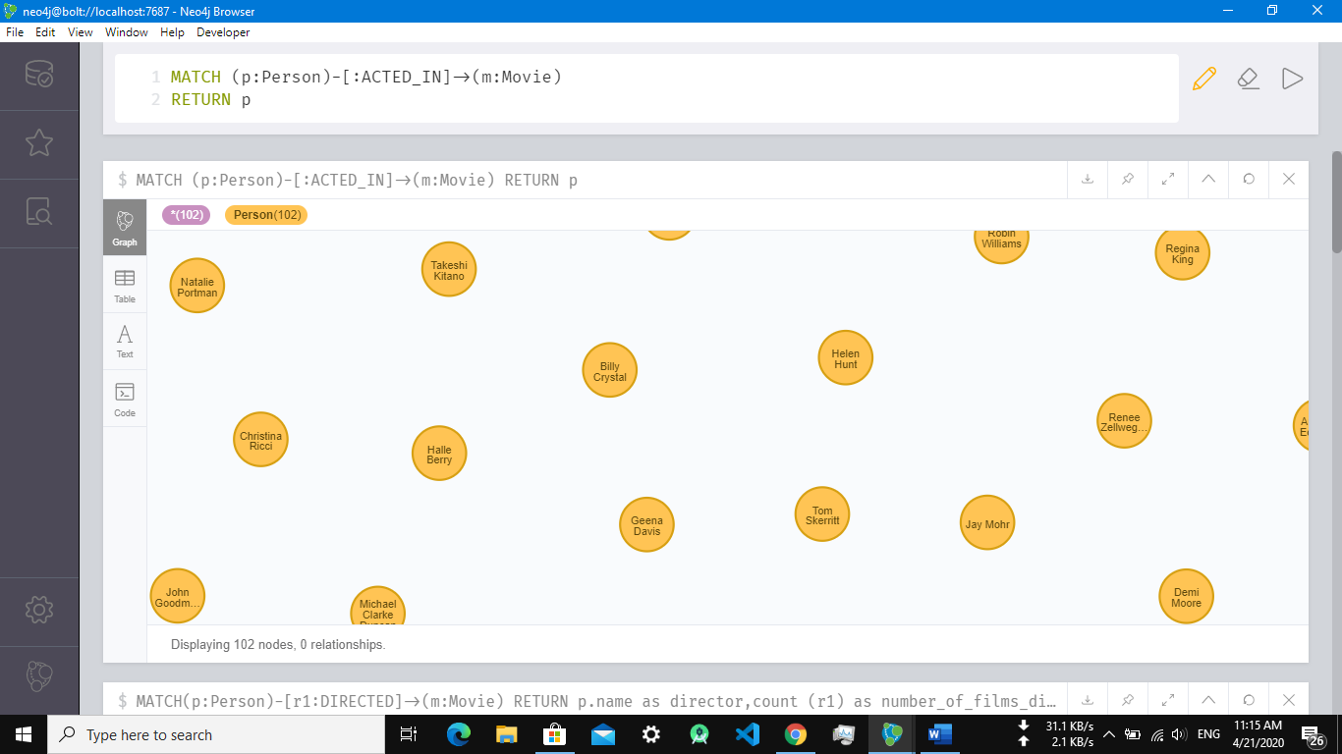

1. Show Person Nodes who acted in any Movie with Movie details:

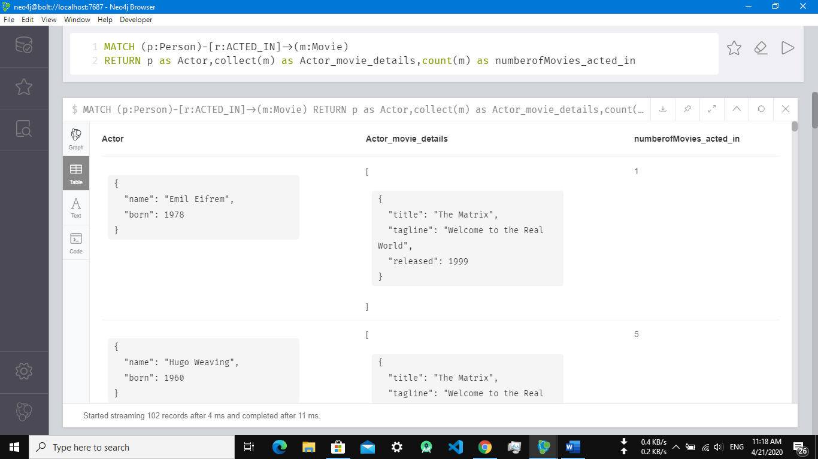

1. Show Person Nodes who directed any Movie:

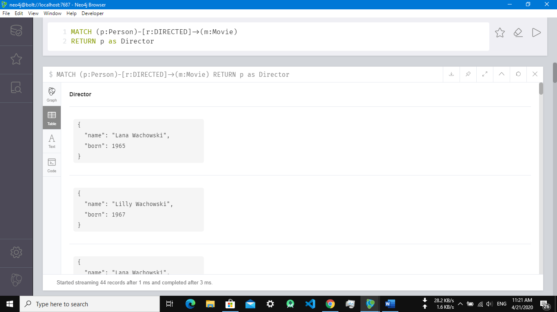

1. Show Person Nodes who directed any Movie with Movie Details:

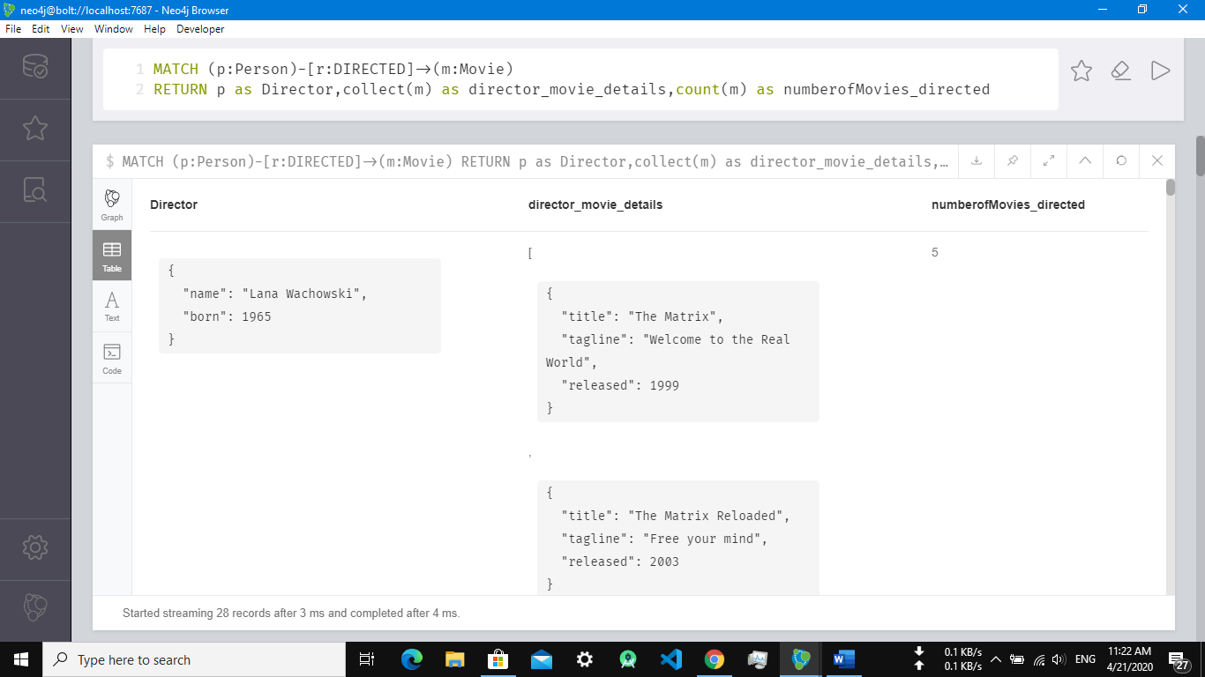

1. Show All Details including Director, Movies directed and acted, and Number of movies acted_and_directed, in which Person Nodes Who are Directors, but they acted also in their own Movie:

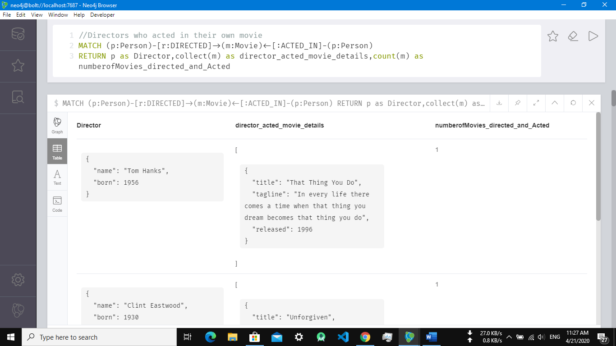

1. Show Movie Title of Person Nodes Who are Directors, but they acted also in their own Movie:

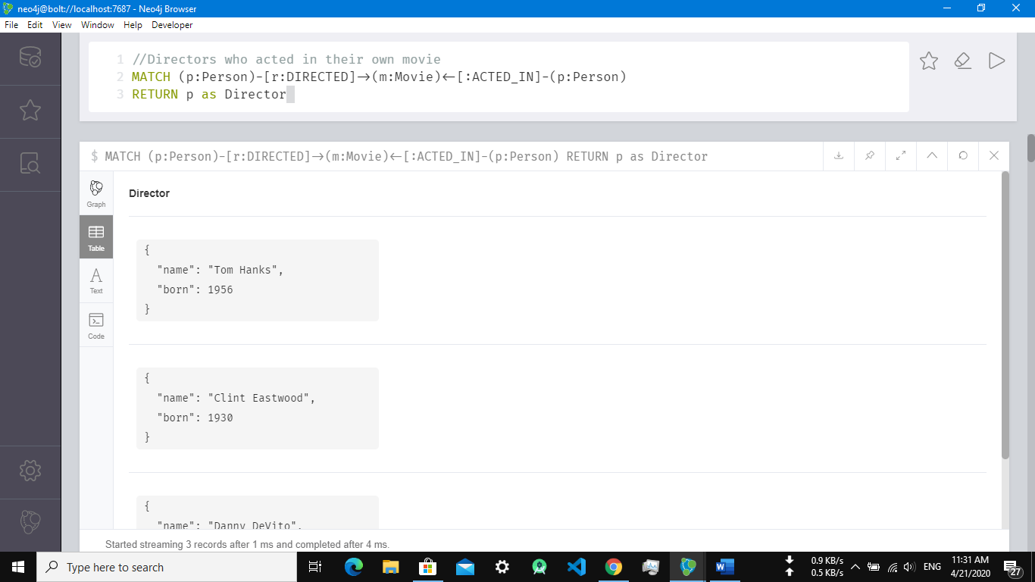

1. Show Movie details who have maximum actors:

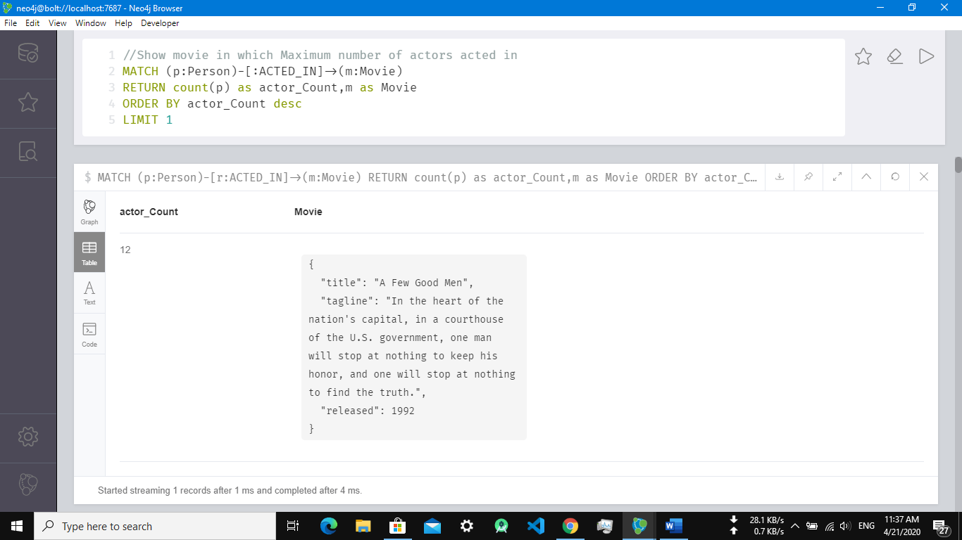

1. Movie which is made with collaboration of different directors:

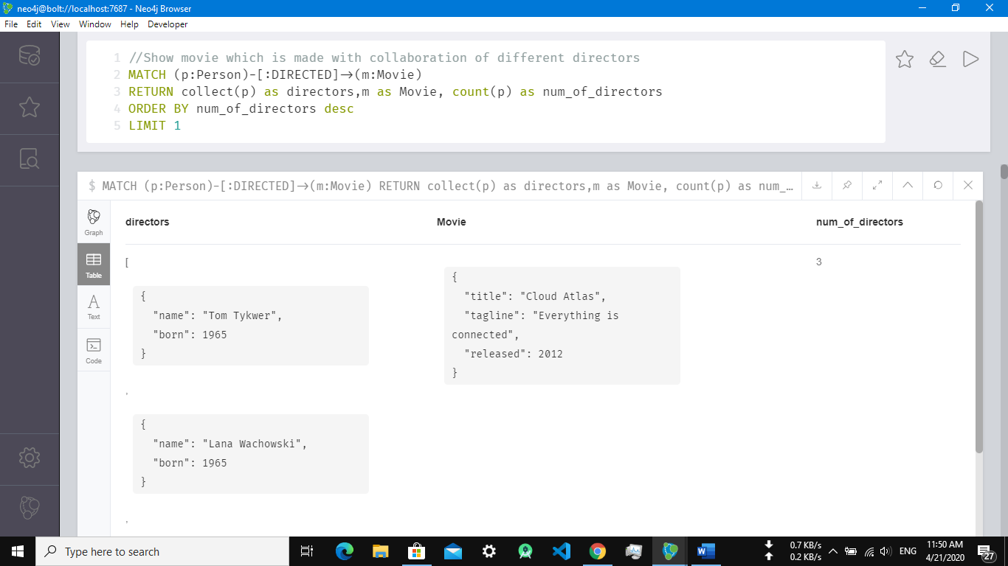

**Important Tasks:**

1. Show most recent year details that has maximum number of movies

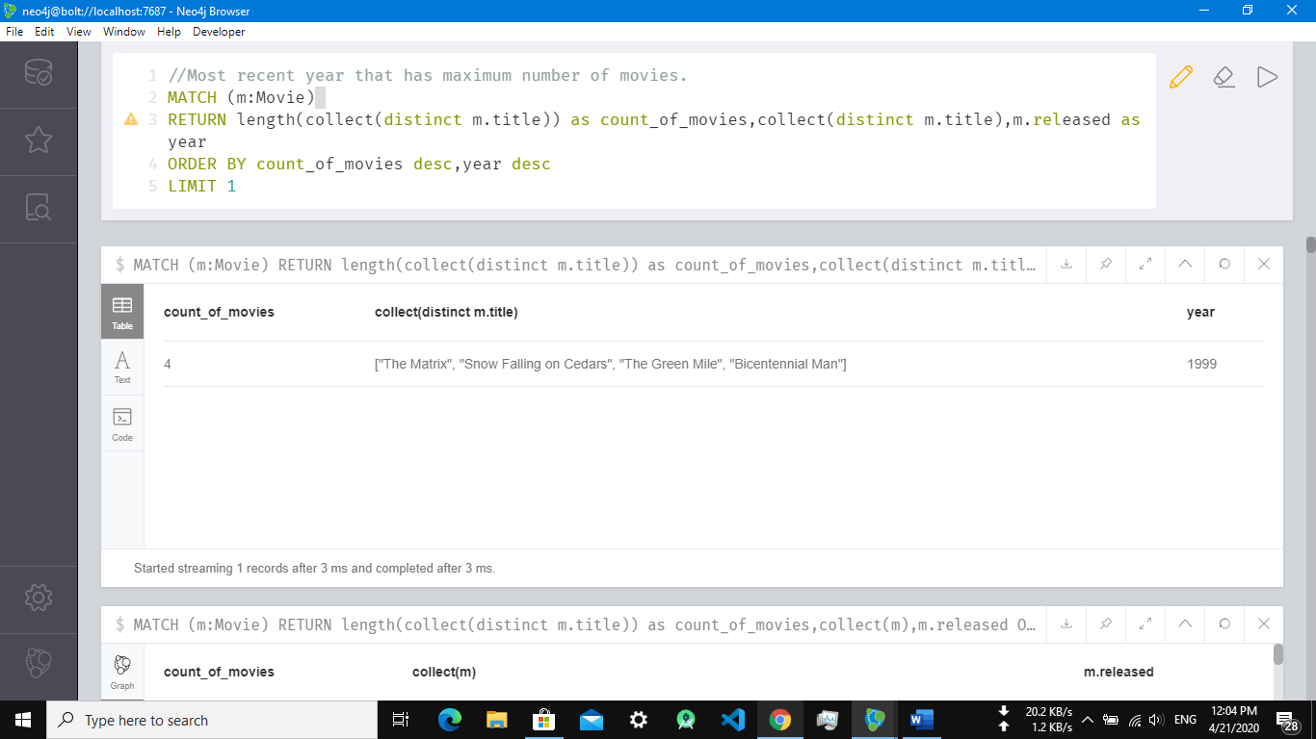

1. Show movies list and count of Most Experienced Actor of Movie:

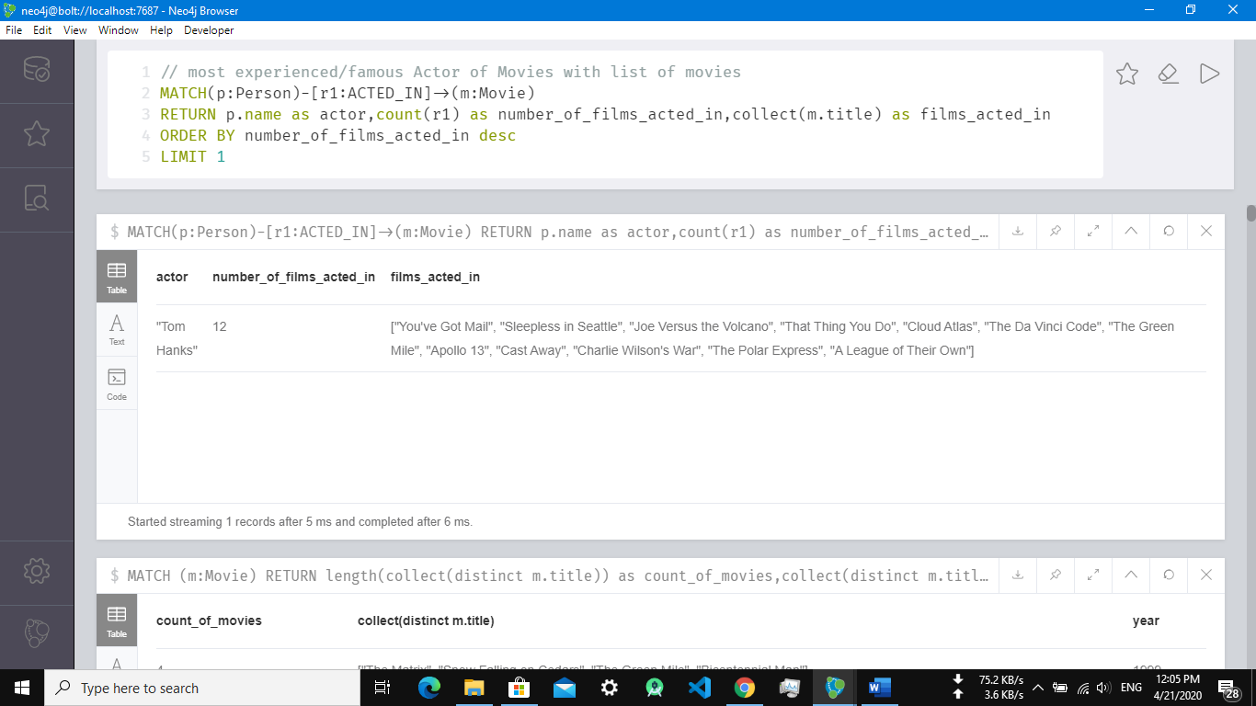

1. Show movies list and count of most experienced Director of Movies:

